St Brendan’s Catholic Primary School
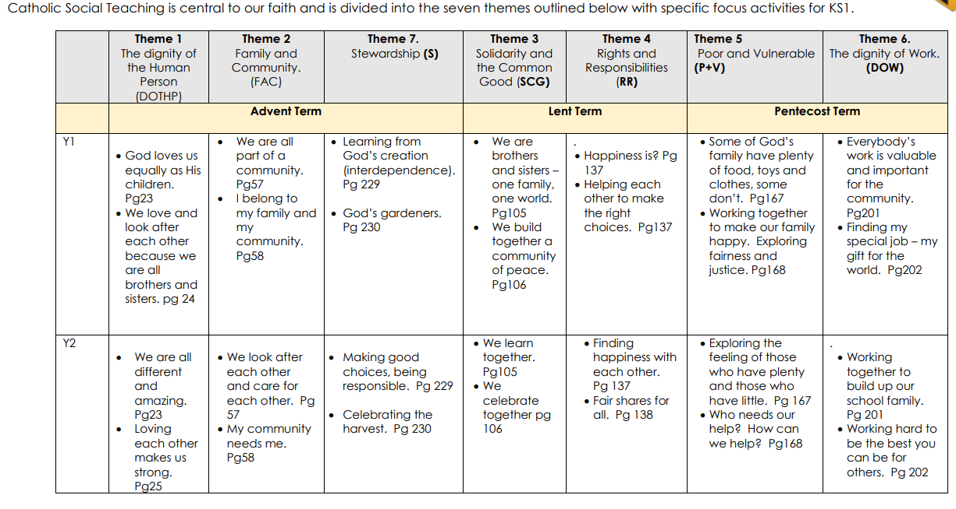
Catholic Social Teaching (Caritas in Action) KS1

