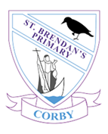
History Rationale
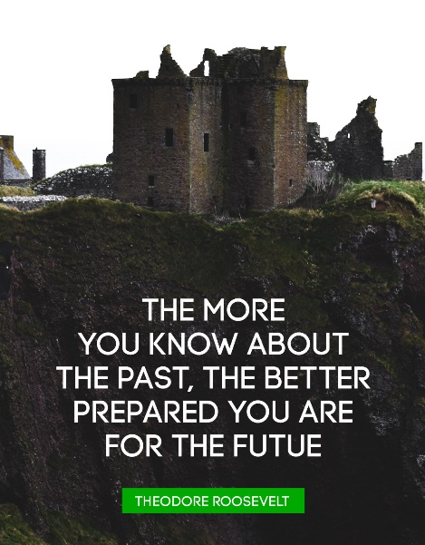
At St. Brendan’s Primary School, we enable our pupils to develop the skills and knowledge required to become curious Historians.
The aim of our curriculum is to develop a long-term memory of events from the past and the impact of these events on our richly diverse society, which children make links with and identify differences and similarities.
Pupils will be taught the skills of historical enquiry, building up a bank of historical concepts and the processes of change. They will learn to ask perceptive questions, think critically, communicate ideas, evaluate reliability of evidence sources and examine arguments.
Whilst History is taught discretely, there are natural links to be made to other areas of the curriculum through the teaching of half-termly lines of enquiry across the school. Long-term curriculum maps ensure there is full coverage of the eras of time required by the end of KS2, as well as robust exposure to an appropriate balance of local, British and World history themes.
The themes in history are the vehicles for the history curriculum. The eras are inter-connected by historical threads (monarchs, exploration, people and society, warfare, local history and Britain). Pupils make links between their learning from one thread to another and from one year to another, as a result of progression planning and assessment. They use this knowledge to make connections between the past and present day and the consequences their actions can have on the future. As well as supporting their development of a sense of empathy and responsibility.
Pupils’ knowledge is regularly assessed through lesson feedback forms and pink papers (at different intervals throughout the year). Pupils are assessed against skills from the assessment milestones for their year group. Milestones are spread across two year groups in KS1 and KS2. Assessment of prior knowledge at the beginning of a theme also helps to identify misconceptions which can be addressed appropriately.
History is brought to life with a series of enhancements to enrich the curriculum, including drama experiences, use of artefacts, trips (both local and national) and visitors to the school. ICT applications are also used to supplement pupils’ experiences. Where possible, pupils’ interests are included in the lessons delivered and opportunities for independent research and enquiry are given to encourage a thirst for learning and promoting creativity.
The school has corporate membership to The History Association, bringing benefits to staff by supporting them with high quality CPD and resources. This aides with teaching and learning as well as developing our own knowledge and understanding.
Monitoring in History includes book scrutinies, lesson observations/learning walks, pupil and parent voice and staff surveys. Pupils’ learning is at the heart of monitoring and informs further developments and adapting of provision accordingly.

EYFS:
Through Understanding the World, pupils learn about past events in their own lives and the lives of those in their family. They talk about heritage and traditions. They also talk about changes that have occurred. The emphasis is very much around themselves and those who are close to them. There are also natural links to Communication and Language, understanding how and why questions. These are taught in different ways through the Characteristics of Effective Learning.
KS1:
Pupils focus on significant people and events, both within living memory (approximately 100 years) and beyond living memory. They should make links between local history and British history. Teaching is planned to build on skills taught previously. These skills include investigating and interpreting evidence. The people studied should reflect our diverse society.
KS2:
Skills developed in KS1 are built upon and pupils are enabled to communicate their knowledge fluently, with a mastery of knowledge. They learn about specific eras (Stone Age to Iron Age; The Roman Empire in Britain; Settlement in Britain by Anglo-Saxons; The Power Struggle of Anglo-Saxons and Vikings; British Monarchy since 1066; Early Civilisation of Ancient Egypt; Ancient Greece; The Non-European Society of The Mayan Civilisation). Through the regular referral to visual timelines and embedding of connections in Historical learning, pupils will develop a secure understanding of chronology.

