[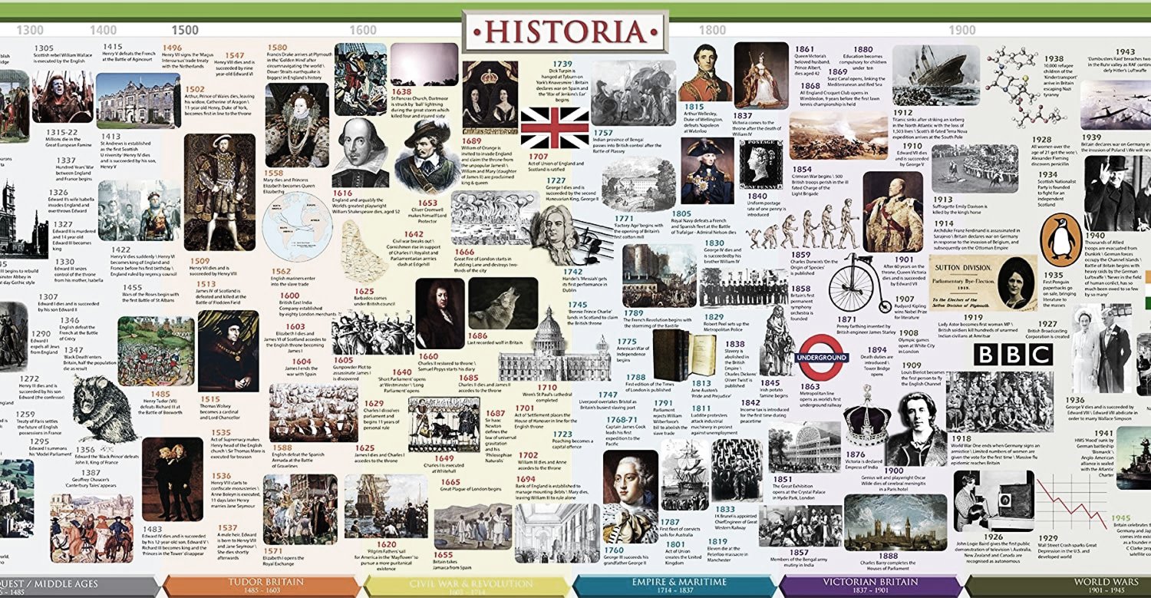](https://www.google.com/url?sa=i&url=https%3A%2F%2Fwww.amazon.co.uk%2FHistory-Timeline-British-Historia-Timelines%2Fdp%2F0956508405&psig=AOvVaw0xC4MMF-EjJzPE0B-plBv_&ust=1585735733213000&source=images&cd=vfe&ved=0CAIQjRxqFwoTCIjA8ZG8xOgCFQAAAAAdAAAAABAD)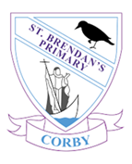

“You can learn lots of cool new things in History that you didn’t know about. Like differences between now and the past and it links to our life now.” (Imogen, Year 5)

**What does History look like at our school?**

History lessons take place in week long blocks, using the progression maps for skills that are to be taught. Blocks are planned with a broad enquiry-based question to introduce learning. Sticky facts are identified and links are made with other areas of learning, including, but not limited to, English, Art and Design, Design Technology, ICT and Geography. It is imperative that History is a driver in History blocks, but can easily become an enhancer to other areas of the curriculum. Initial lessons are used to contextualise the area of study; looking at pupils’ prior learning and when on the timeline the new learning will fit in. Pupils are then given time to compose their own questions. An enquiry approach is then used to teach the pupils about the Historical focus. Sticky facts are shared with the pupils and ways are developed together to help them to remember (use of organisers). Pupils will learn about local, national and world impacts of their historical aspect. Lessons should comprise of a range of teaching strategies, including pupil-led work, such as gallery techniques. Pupils record their learning in a variety of ways in their work books. They take pride in the presentation of their work and use skills taught in other lessons (English, for example). They are given time to reflect upon their own work as well as be a critical friend to others. Feedback can be verbal or written and is focussed on the History objectives. Teachers make notes and annotate planning to assess where the pupils are working at. Enhancements, such as visits and visitors are integrated to maximise learning.

**Why is History important to learn?**

As part of a broad and balanced curriculum, History provides pupils with a sense of context. It improves their general knowledge, by introducing key facts. History is fundamental in the understanding of British Values. Pupils need to know about the history of democracy and the impacts of changes in society, in order to understand present day culture and our place as citizens today. Through chronological understanding, pupils are supported in organising their thinking in other areas of the curriculum. Historical understanding aids pupils’ metacognition, through the use of timelines, mind maps and organisational thinking. Pupils use their learning journey to reflect upon their learning, then can communicate their learning to others. History links to the 5 ways to wellbeing, equipping pupils with life-long skills which can be used across the curriculum and in their future roles. History lends itself to many different learning styles; exploring artefacts as a kinaesthetic approach, investigating sources and communicating ideas which can be completed socially in teams or as a solitary experience.

**Opportunities to celebrate History in our school.**

We promote passion and enthusiasm for History and exploring the past through all our lessons. Pupils are encouraged to ‘be historians’ in the weeks that are dedicated to History curriculum time. Following a line of enquiry approach is key in motivating pupil and sparking an interest in the recent and distant past. Pupils are encouraged to ask their own questions, which are displayed in the classroom or in pupils’ books. When the answers to these questions are discovered, pupils gain a sense of achievement for finding the information out. Work that has been completed independently at home as an extension of curriculum history is shared and rewarded in class and displayed prominently for the class to admire and reflect on. Displays in the environment include excellent examples of pupils’ work, which sets high expectations for all.

“I like to learn about things from the past that I find interesting.” (Colin, Year 2)

History at St. Brendan’s Catholic Primary School