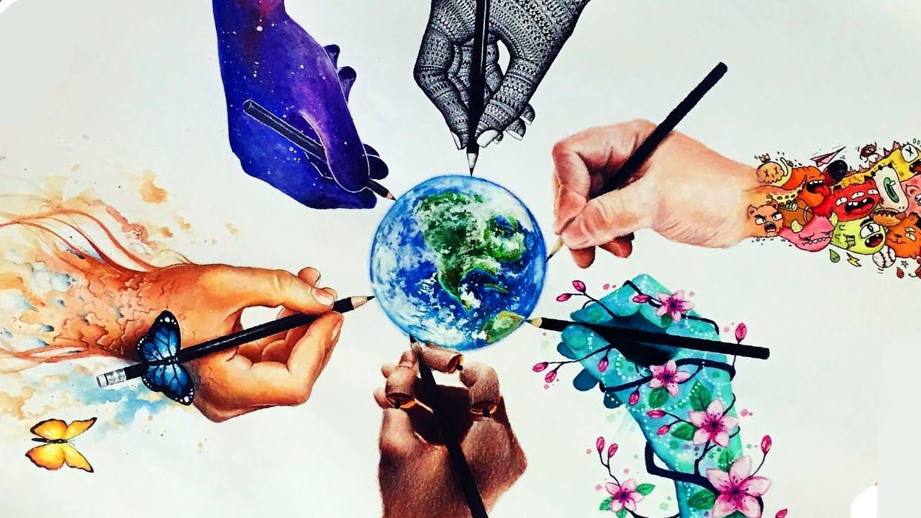.,

**What does Art look like at our school?**

In our school, Art is embedded into all aspects of learning to encourage children to explore art in a variety of ways, from connecting meaning in artwork to noticing different artistic styles. Children start by learning key skills, which progress through the year groups. They also research different artists, refine their skills, form their own artistic opinions, create their own pieces and reflect upon their work. Children are able to communicate which artistic styles have influenced their work and what skills they have used. All children work independently and collaboratively to develop artwork that expresses their thoughts, feelings and imagination. We encourage children to share ideas and to reflect on what worked well and what they can do to improve. Children act as ‘critical friends’ to encourage and support continued artistic development. At our school, it is our aim to give children full ownership of their artwork and provide them with the confidence to explore, experiment and make their own decisions.

Art provides challenges for learners at all levels.

Art gives me the freedom to express myself

Year 6

I enjoy art. I can create anything I want.

Year 2

**Opportunities to celebrate Art in our school.**

In our school, children’s talents are recognised and praised. Children’s work is celebrated throughout the school and displayed in many areas. During the year, there is a fantastic celebration of Art where children can display their artwork in a gallery-like style, which provides us with a great opportunity to invite parents and careers to come and celebrate the children’s artistic achievements.

**Why is Art important to learn?**

* Art benefits children in every aspect of their lives, It develops motor skills, language skills, social skills, decision-making, risk-taking, and imagination. It helps learners to develop creative problem-solving skills and allows difficult concepts to be presented visually. It also allows students to make connections with their own culture as well as with the wider world. Art encourages self-expression and creativity and can build confidence as well as a sense of individual identity. Creativity can also help with wellbeing and improving health and happiness.

Art at St. Brendan’s Catholic Primary School