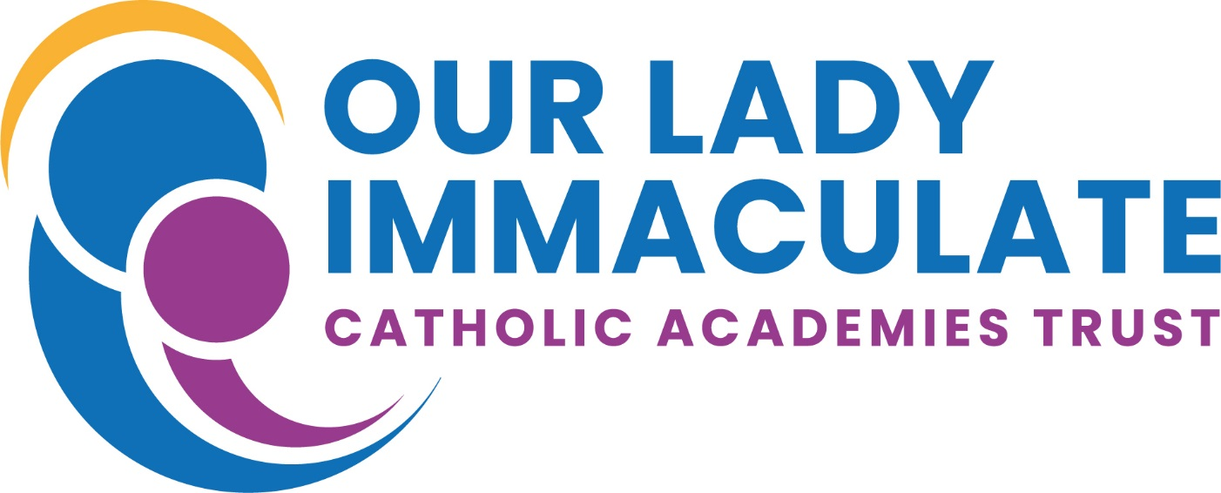
St. Brendan’s Catholic Primary School
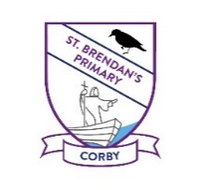

Religious Education Policy

Approved Date: January 2020
Review Date: January 2022

‘Always treat others as you would like them to treat you’.

(Matthew Ch 7 v 12)
Introduction
In the light of our mission statement RE is taught here at St. Brendan’s Catholic Primary School because we aim to put it at the heart of the curriculum so that it becomes the starting point of all other experiences. Together with the parents and the parish of St Brendan’s we work in partnership towards educating our pupils within a Catholic context.
We wish our school to be a community of faith, in which each member participates, fully aware that all our work and aspirations derive from Jesus Christ.
We believe that the ethos of our school is of prime importance, as our children are sensitive to learn from the atmosphere and attitudes within the school. Our aim is to permeate all aspects of education in our school with Gospel values, creating a Catholic Christian community, where all education goals are rooted in Christ and in his Gospel and we are reflecting God’s purpose in our undertakings.
Religious Education at St. Brendan’s Catholic Primary School
RE provides an opportunity to foster in our children a reverence and love for God, an understanding of the Gospel of Jesus Christ and to help them identify themselves as Christians in the Catholic Church, developing traditions of our Catholic faith.
We aim to promote:
- Knowledge and understanding of Catholic faith and life.
- Knowledge and love of Christ within the Sacraments.
- The skills needed to engage in examination or reflection upon religious belief and practice.
- The needs of all our children knowing that some of them will be from committed Catholic homes while others will not.
- The celebration of RE for our pupils through shared assemblies and liturgies.
- A spiritual dimension to the lives of the pupils and the liturgical year is reflected in the life and activities of the school.
- Positive attitudes towards people of other faiths and other religious traditions in relation to God.

Aims and objectives
- To develop a knowledge and understanding of the mystery of God, of Jesus Christ and the Church and of the central beliefs which are held by Catholics.
- To develop an awareness and appreciation of the Catholic faith and of how it affects personal and social behaviour and of the vital relationship between faith and life, life and faith.
- To encourage investigation, reflection and evaluation of the truths of our faith by the pupils.
- To foster appropriate attitudes e.g. respect for truth, respect for the view of others, awareness of spiritual, of moral responsibility.
- To foster an awareness of the demands of religious commitment in everyday life and especially the challenges of living in a multi-cultural, multi-faith society.
- To develop appropriate skills e.g. ability to listen, reflect, to pray to and to be aware of God, to acquire knowledge and organise it effectively to make informed judgements.
- To educate the whole person and to find a balance between knowledge of doctrine, response to worship and personal and social development according to Gospel values. For a truly balanced education in faith we believe each individual must be treated with equal importance.

Entitlement
RE is regarded as the heart of the curriculum enriching and informing all areas of learning. RE must always deepen pupils understanding of Catholic belief and contribute to their education in the Catholic faith.
Visits from speakers representing other Christian denominations and other faith groups will be encouraged in order to strengthen links with the wider community.
To fulfil our aims and objectives of educating all our children in religion we use the religious programme “Come and See”. We use a whole school approach that explores the same topic at the same time, though of course at the appropriate level of the year group.
RE is to help develop a knowledge and understanding of the concept of the Catholic faith and foster reverence, awe and wonder.
Religious Education gives shape and is linked to the whole curriculum; every part of it is ultimately related to God. We teach to further children’s faith development not only through lessons and activities relating to a formal programme, but through prayer and worship and most importantly by examples.
Religious Education is taught for 10% of curriculum time in all classes. EYFS and KS1 – 2 hours a week KS2 – 2½ hours a week All teachers are responsible for developing the RE of the pupils in their class. The RE Subject Leader and the Chaplaincy Team are always willing to support non-Catholic teachers with their planning and in preparing lessons.
RE lends itself to all areas of the curriculum and will be linked to other curriculum subjects.
Planning, assessment, recording and reporting
All staff complete and annotate the RE topic planning -The RE Subject Leader is always available to support new members of staff with their planning.
Pupil’s work is recorded in a variety of ways e.g. pictorial, written, wall displays and photographic evidence.
Work is marked according to the school marking policy. It is marked sensitively and positively. Often oral feedback is given to children when their work is being corrected – especially in KS1 or when the children are taking part in verbal presentations, class discussions and debates.
Teachers formally assess pupil’s knowledge, understanding and appreciation of Catholic belief and practice appropriate to their age and development, their knowledge of scripture, understanding of God’s message and their moral development and attitudes.
Children complete a Come and See assessment task at the end of each topic.
Pupil’s progress is reported to parents informally during parent’s evenings and formally at the end of the year in pupil’s annual reports.
Staff and responsibilities
We aim to demonstrate our own faith and commitment as a staff, in partnership with our governors, priests and parents. The RE Subject Leader is available to staff to offer advice and support if requested. The RE Subject Leader attends appropriate courses that are provided by the diocese and then provides up-to-date information to staff. The RE Subject Leader meets termly with other Subject Leaders within the Olicat Trust.
Budget
Each year the RE Subject leader has a budget for the purchasing of resources relevant to the Come and See programme.

At St. Brendan’s Catholic Primary School, Religious Education is a core subject of the curriculum. All future development, in the light of our Mission Statement will be aimed at continuing to create an environment where the gospel values of prayer, truth, holiness, justice, love and forgiveness are seen to be at work within our school.

